**Round Trip Phase Measurement Scheme Analysis**

**Sidhant Guliani**

**31/01/2018**

**Introduction**

This document describes the Round trip phase measurement experiment done in summer 2017. The purpose of this experiment is come up with gain model for 50m coaxial cables. In earlier analysis, we tried to develop a model based on delay calculation. Now we are trying to use Temperature as the parameter in a model.

**Experimental Setup**

A

B

FLA

LNA

Terminator

Stone Correlator

Splitter

**WRH**

The plus sign in the figure represents the Dual-Polarized feeds and red line is the reference cable, which is 2m SMA cable. The whole experimental setup is described in Doclib# 0496. For the signals through the focal line there is one 2m cable between splitter and outer bulkhead, 2-50m cables to the focal line and back, there is 1 2m cable from outer to inner bulkhead and one 2 m cable from inner bulkhead to correlator. For the reference channel (Red) there is one 2m cable from splitter to inner bulkhead and one from inner bulkhead to correlator. During this setup, cable trays were not covered, the FLAs were not installed. We are using FLA, LNA and terminator as noise source. The 2-50 m coaxial cables were connected using 1 ft cable at focal line. For this experiment, we used Stone correlator and data is Archived in gong.

**Analysis**

Data was collected for roughly 1.5 months. While analysing data, we saw that during some period the data was corrupt, refer to figure 4, doclib 496 (blue curve, frame 1000-1300). After masking this corrupt data, we are left with roughly 1 month of data. In total, there are roughly 3000 frames. Cadence during these acquisitions was set to 10 min. Currently, data that I’m working on is in broken pieces.

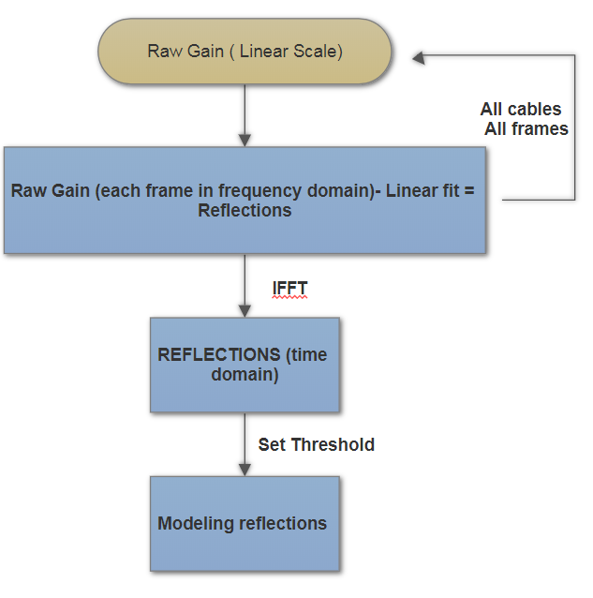

Figure 1: Flow chart presenting how we are getting reflections.

The Flowchart above describes the steps used to get the reflections for cables at 600 MHz. The purpose behind this experiment is to come up with a thermal model for the gain variations of 50m coaxial cables. Raw Gain is calculated using:

The gain calculated is in linear scale, for each frame and in frequency domain. Linear gain is unitless, as it is fraction of cross correlation of that channel with reference channel and autocorrelation of reference channel. The gain for 1 channel and single frame is mentioned in figure 2. The ripples in the plot represents multiple reflections in single channel. To begin with, we fitted linear line on gain plot and subtracted raw gain from fit. These reflections are due to multiple cables/connections in single channel and they are temperature dependent. Linear fit to raw gain has 2 parameters: Slope and Y-intercept. Our next step will be to check how these parameters are changing with time/temperature. Figure 5 shows the reflections in the cable at that instance, different colors represents different channels. These reflections are temperature dependent. Now we want to check how reflections are varying in a single channel over time, can we model them from weather data? Figure 6 shows reflections for one channel and 800 time frames. As mentioned above, that the cadence for these acquisitions was 10 minutes that makes 800 frames to be 5.5 days. It seems that the curve follows each other fairly well. But there might be some structure present in them that we are not seeing in this plot. To see that structure, we picked from figure 6 as reference and subtracting it from other curves, shown in figure 7. If we slice the data, i.e. pick one frequency and see how much these residuals of reflections are varying at that frequency. Figure 8 shows these residual reflections for 4 different frequencies. Black curve in this plot represents Air temperatures for that period. Note, we are using outside temperature. It seems that ripples in gain are driven by temperature. There seems to be some lag between both curves. To see how we are doing at other frequencies we sliced figure 7 at all frequencies and plotted them against time, we get figure 9. Two black curves here represents scaled Air temperature data.

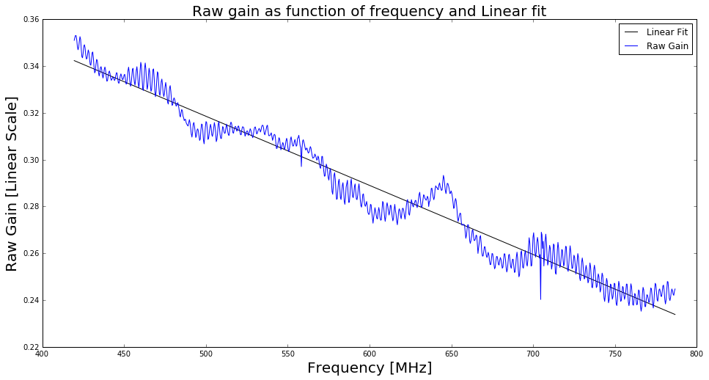

Figure 2: Raw gain as function of frequency for single channel and single period. The linear fit for the plot, in black line represents direct component of signal. If we subtract gain from fit, we will get reflection in this channel for this period. We want to check if we can model the reflections and the linear fit as function of temperature. There are two parameters for this linear fit: Slope and Y-Intercept, in later plots we will be checking how are these parameters varying with time. If they are, how closely are they following temperature. There are two parameters for linear fit, Slope and Y-intercept. We want to check how these parameters are varying with Air Temperature.

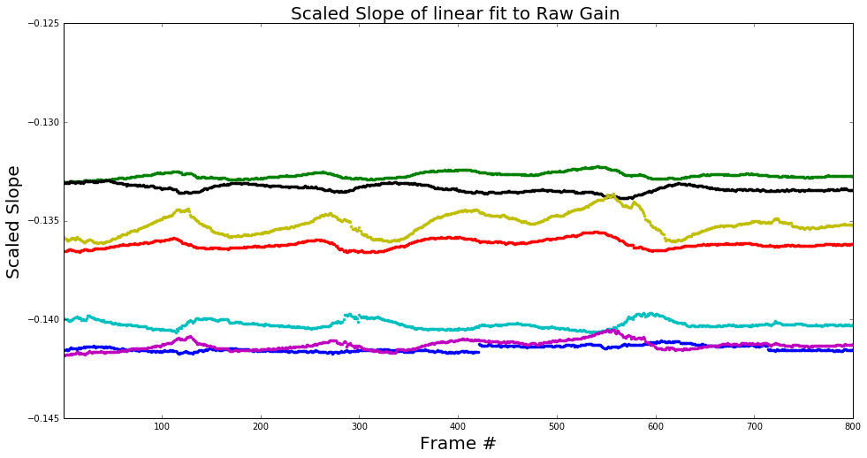

Figure 3: Scaled slope of the linear fit to raw gain for first 800 frames, roughly 5.5 days. It seems that slope is varying maximum of part in thousand.

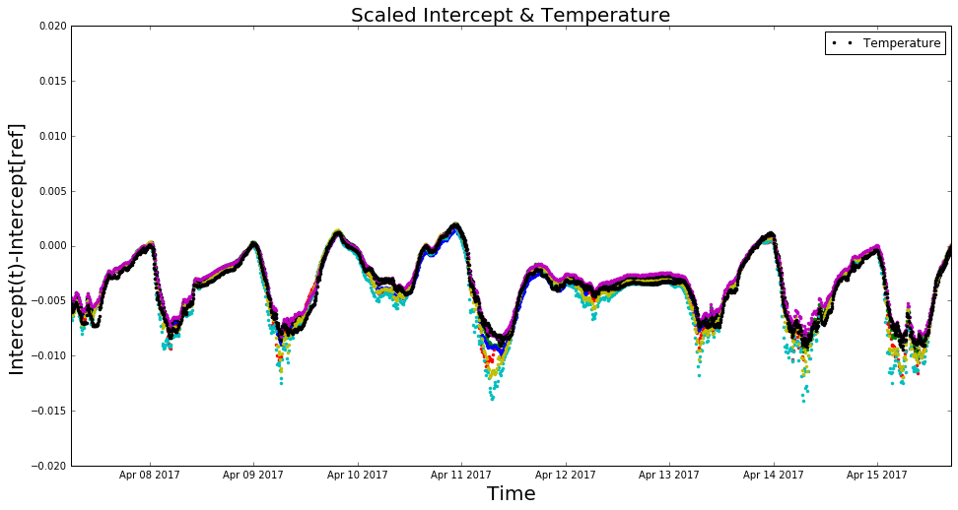

Figure 4: Scaled y-intercept of the linear fit to raw gain 2000 frames, 14 days. The black curve here is scaled air temperature data. It seems temperature tracks Y-Intercept very closely.

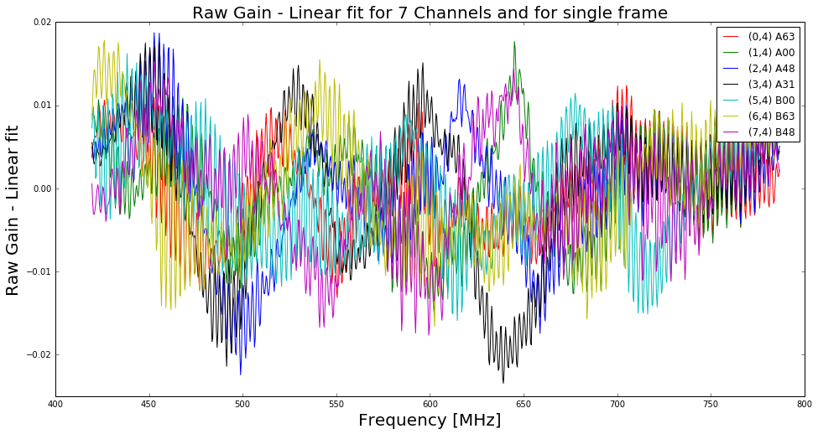

Figure 5: Residual of Raw Gain and Linear fit as function of frequency for 7 channels and single period. In other words, these are reflections in 7 different channels for a period. The reflections in each cable seems different.

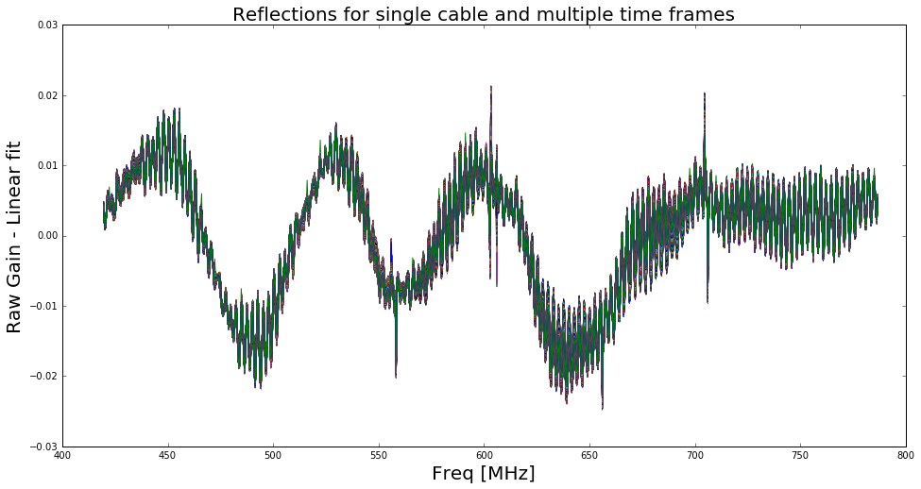

Figure 6: Reflections for single cable and 800 time frames, roughly 5.5 days. The curves looks like following each other, but there might be some small scale structures present.

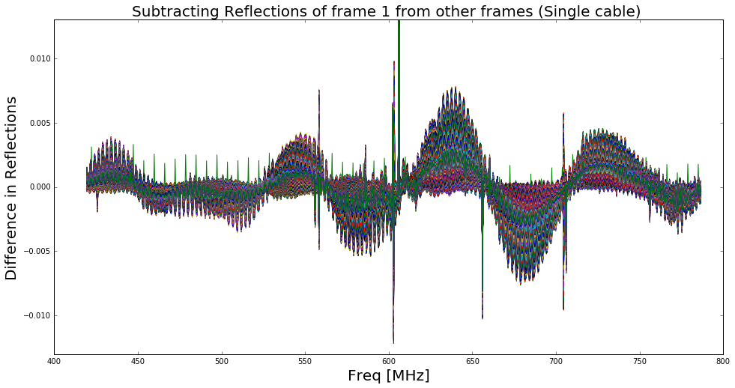

Figure 7: Picking one curve from figure 4 as reference and subtracting it from other curves. This is done to check how much structure is left in the reflections for different times. If we slice the data, i.e. pick one frequency and see how much reflections are varying at that frequency.

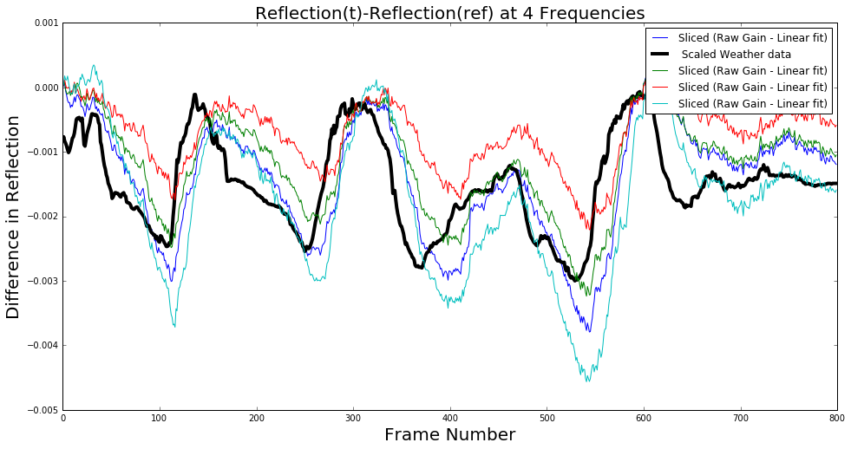

Figure 8: Slices of figure 5 at 4 different frequencies plotted against time. The four frequencies are: f1= 478 MHz (Cyan curve), f2= 578 MHz and 2 adjacent frequencies to f2. The black curve is air temperature, we are using the outside temperature. It seems that ripples in gain are driven by temperature. There seems to be some lag between both curves.

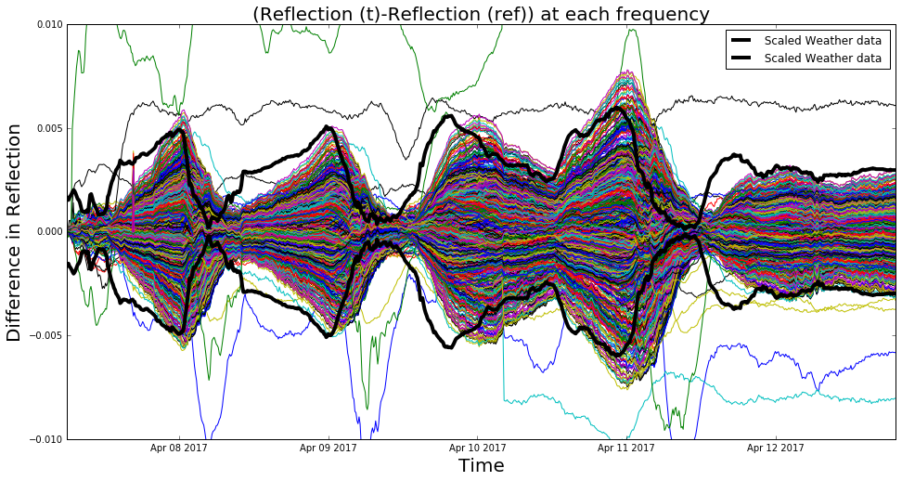

Figure 9: Difference in reflection for different frequencies. There seems to be some lag between temperature curve and residual reflections for all frequencies. Figure 10 show the absolute value of IFFT of all reflections for single cable and single frame. We see that there are few peaks and peaks in lower side (left) are due to reflections in shorter cable and peaks in the middle are due to long cables.

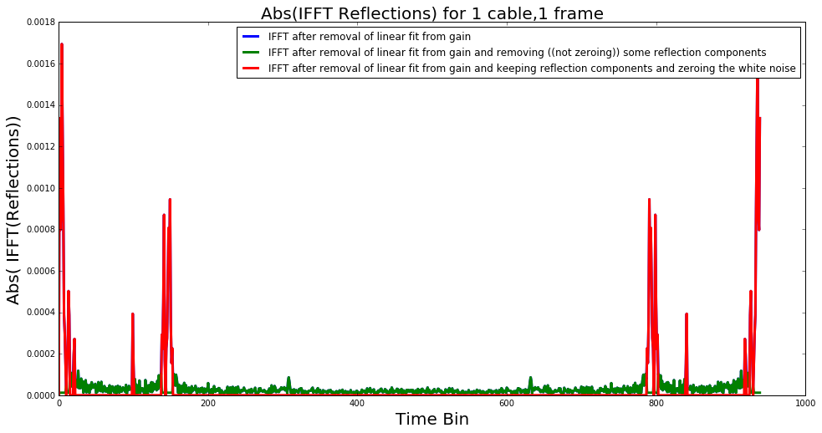

Figure 10: Absolute value of IFFT of all reflections for single cable and single frame. We see that there are few peaks and peaks in lower side (left) are due to reflections in shorter cable and peaks in the middle are due to long cables.